HANGING GARMENTS
*PLEASE SEE VIDEOS*

With garment facing you, the hanger hook should curve to the left looking like a question mark (?) and simply hang the garment.
Only pin shirts IF they will easily slide off the hanger.

SETS
Place top over the hanger, first, then pin pant/skirt/short from each side of waistband to the backside of top, through hanger, at the shoulders.

PANTS
Pants, shorts, and skirts should be opened up lengthwise (not folded!) and pinned with MEDIUM or LARGE safety pins, at waistband, to the upper bars on each side of hanger. The FRONT of the pants/skirt should be facing you. Older girls and older boys pants/shorts should go through the belt loops and then be pinned at the waistband. This gives the added support those heavier garments need.

TAG PREP

ITEMS NEEDED:
16 inch Metal hangers ONLY
Index cards or cardstock paper ONLY
Ink pens
Red ink pin
#2 safety pins
Clear packing tape
Duct tape or masking tape
Masking tape or small dot labels
Variety size of baggies
Zip ties 8 inch or 10 inch

Below is how your KCC tags must look. You have 3 choices of how to prepare them and they are listed below. Any way you choose is fine BUT THEY MUST BE ON 3x5 INDEX CARDS or CARDSTOCK PAPER. WE WILL NOT ACCEPT tags done on copy paper or any smaller or larger than 3x5. KCC has been preparing tags this way for years and these are the instructions. NO EXCEPTIONS!
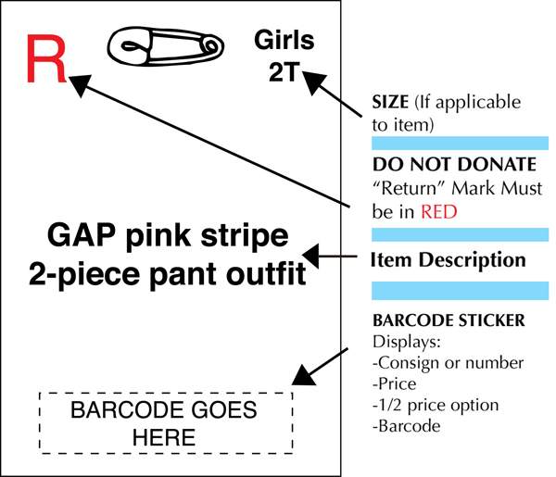

*The red R is only for those consigners who wish to have an item returned and MUST be in RED INK and in the left hand corner. If you are donating your items simply do not put a red R.

*Safety pin is horizontal.

*Girl, boy, junior, ladies and size goes in the right hand corner.
Size should be written as follows.
Infants: newborn (NB) or 0-3mo; 3mos or 3-6mo; 6mo or 6-9mo; 9mo or 9-12mo; 12 mo or 12-18mo; 18mos, 24mos.
Toddlers: 2T, 3T, 4T/4
Children’s/Teens: 5, 6, 7, 8, 10, 12, 14, 16, 18, 20 / bigger boys waist sizes up to 34.
Juniors: XS, S, M, L, XL or odd sizes ~ 0, 1, 3, 5, 7, 9, 11, 13, and 15.

*Be sure to give a detailed description to help keep your items safer by deterring tag switchers and helps KCC get lost tags back with an item so we can sell it.

*Barcode goes at the bottom of the tag.

* To attach tags to clothing, use MEDIUM #2 safety pins only ~ NO SMALL safety pins or straight pins. Attach tag to upper right side of hanging garment as you are looking at the front of garment with hook facing left.

*Once your tag is pinned to the garment on the upper right side, place packing tape over the tag from top to bottom, covering the safety pin. This added security is for those consigners tagging expensive items AND A MUST for those who are bringing BOUTIQUE ITEMS.

*Choose one of the below options for your tag – A, B, or C for creating your KCC tags, on which you will later affix your barcode labels. Do not change the size or shape of these tags, they should be no larger or smaller than a 3 X 5 index card!

A) Index Cards – HANDWRITE on a 3″ x 5″ (ONLY) index card in vertical orientation See above illustration.

B) Tag Template– See “Tagging Templates” Button (CARD STOCK ONLY)

C) Tag Template– See “Tagging Templates” Button (CARD STOCK ONLY

PREPARATION OF YOUR ITEMS:
MOST IMPORTANTLY - watch our video tutorials on how to properly hang and tag items AND what we will and will not accept. We will NOT accept an item that is NOT PROPERLY TAGGED, HUNG OR WHAT WE ARE NOT ACCEPTING. I would hate for you to prepare items incorrectly and then get here and we send you away to fix them. That is a huge waste of your time and ours!

- Check items for recalls. We cannot sell a recalled item and it is your responsibility to check BEFORE you bring it. Actually it is against the law to sell something that has been recalled. The consigner agreement and waiver you signed when you registered lets KCC know you have cleared the items for selling. Please click on the link below to check on items that may be recalled
. https://www.cpsc.gov/Recalls

- Treat stains and wash clothes.
- Wipe toys, outdoor items, baby equipment, etc.
- To add value to your clothes, press garments that are wrinkled.
- Use a lint roller to remove pet hair.
- Button, snap and zip items.
- Be sure the garments are seasonally appropriate.
- Remove any thrift store or yard sale price tags, as they devalue your items. Retail price tags are FINE to leave on as they increase the value showing potential buyers that the item is new!
- Also, put a piece of masking tape/sticky label with consignor # only inside of your garments and on all other items. This is for your protection should an item loose a tag.
- Any sale items, WITHOUT a separate piece of tape with Consignor #, that loses a tag, will be donated to a charity and that consignor cannot expect to receive credit for these items.

How to Package Non-Clothing Items:

- Batteries in ALL Items: BATTERIES are required for all equipment such as bouncy seats, electronic pack n’ plays, exersaucers, jumperoos, walkers, AND battery operated toys,
- Cribs, pack-in-plays, baby swings, etc. MUST be fully assembled by consigner at receiving and any accompanying small items securely attached!

Toys:
Place a small piece of duct tape, masking tape or clear packing tape at the top middle of your tag. Using a hole punch, punch a hole in the center. Take a zip tie and thread through the hole and attach to a knob, leg, wheel, etc. of the toy.
*Ones with extra small parts: Place in a Ziploc and SECURE to the toy to avoid separation using clear packing tape or a zip tie.
*Toys that are to small to attach the tag, place in a Ziploc and secure with clear packing tape across top of bag. Tag should be taped inside of bag.
*Large toys: Place a small piece of duct tape, masking tape or clear packing tape at the top middle of your tag. Using a hole punch, punch a hole in the center. Take a zip tie and thread through the hole and attach to a knob, leg, wheel, etc. of the toy.

Books:
Use masking tape to adhere the tag to the back or front of the book because usually masking tape will not tear the paper. For a set, place in a Ziploc, with tag inside and close adding packing tape to secure. ***Most secure way to sell books is by placing in a Ziploc. Tags do get torn off during the sale and 99% of the time we do not find the tag so we end up giving the book to charity.

Puzzles:
Use clear plastic wrap or shrink wrap to cover and place tape ONLY on the wrap. Do not put tape on the actual puzzle pieces because it will tear off the print when removed! Once puzzle is covered in plastic wrap, use clear packing tape to secure the wrap and tape your tag to the back of the puzzle.

Shoes:
THREE things are VERY IMPORTANT & REQUIRED for the safety and security of your shoes. If these are not done correctly, you will have to take them home to redo.
- 1)Zip tied together
- 2)Connect the tag to the shoes
3) The use of duct tape, masking or clear packing tape on tag.
Connect the shoes together using zip-ties/cable ties by looping the zip-tie through a shoe-lace hole, loop on heel, or a strap that cannot be adjusted. If you do not have anything to loop through, put your shoes sole to sole and use zip ties to tightly wrap around the midsection of the shoes to keep them together. Simply zip tie your tag to the existing zip tie.
For boots - Use the zippers of boots to connect together. Zip tie boots together and add an additional zip tie for your tag.
Take your tag, place a piece of duct tape, masking or clear packing tape at the top middle. Using a hole punch, punch a hole at the top, take a zip tie and go through the tag and attach to the other zip tie.
Helpful hint: Walmart, Target, Dollar General, Harbor Freight sells zip ties. They may be called cable ties and can usually be found near the outlet covers, extension cords, etc. The 8 inch should be long enough but 10 inch may be used as well.
- Put a piece of masking tape with your consignor # on the bottom or inside of each shoe in case the tag somehow gets torn off.

Misc items:
Bibs, burp cloths, receiving blankets, baby towels, wash cloths, socks (new only), tights, mittens/gloves, hats, sippy cups, kitchenware for children, belts:
Place item or items that are the same gender together and place in a baggie. Add you tag in the bag and secure tag with clear packing tape. Fold the bag over to fit the contents of the bag and seal with packing tape.

Claim ticketed items:
All strollers, highchairs, bikes, pack-n-plays, cribs, large doll houses, beds, changing tables, gliders, rockers, exasaucers, car seats, swings, and household furniture MUST have a claim ticket. When you come to receiving, a KCC worker will help you.

Sort:
Clothes must be sorted by size and sex within each category. NO EXCEPTIONS! If you have just a few items of different sizes, have them in order by size and sex.
Categories are: Children’s boys, Children’s girls; Boutique boy clothes boutique girls, juniors, ladies boutique, Christmas clothes, Halloween costumes/clothes; Collegiate clothes, or sportswear (baseball pants, football pants) from other clothing items as they will not be displayed together.
All other items should be grouped together, i.e. toys (including games, puzzles, arts/crafts) in a bag/box; shoes in a bag/box; children’s misc. items such as bibs, hats, socks, bows, bottles, safety items, etc.

